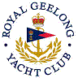 | Royal Geelong Yacht Club Inc.  Est 1859
Trophy Deed of Gift.

Trophy: | Guyon Wilson Trophy
Presented by: | Guyon Wilson
Date: | 2022
For: | Etchells Series, January Regatta
Remarks / Revisions | For Pseudo Etchells as well
Click HERE for a List of Recipients

